Project Title:
Analyzing Mobile Sales Dataset

1. Open Tableau and Load the Dataset
- Launch Tableau Desktop.
- Go to File > Open, and select the Mpobile_Sales_data
- .csv
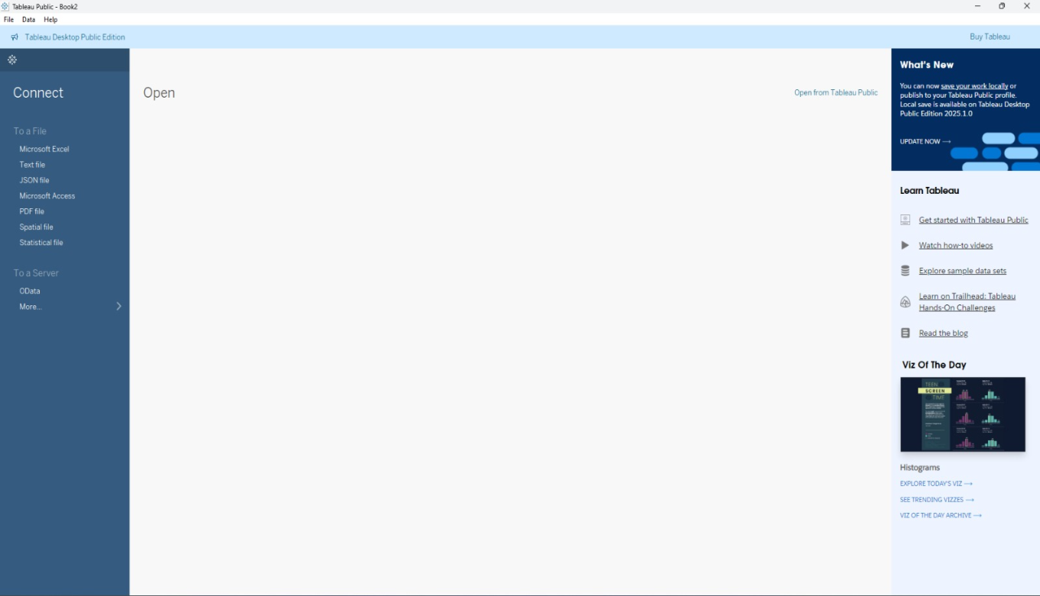

📑 2. Connecting to Data
- Tableau will automatically load the dataset embedded in the .csv file.
- Navigate to the Data Source tab to review the fields, such as:
- Brand
- Co specification
- Customer name
- Product
- Price
- Which mobile brands generate the highest total revenue in the dataset?
Step 2: Create the Bar Chart for Revenue Analysis
- Drag Brand to the Rows shelf.
- Drag Revenue to the Columns shelf.
  - Tableau will automatically aggregate the revenue as SUM(Revenue).
- Sort the bar chart by revenue:
  - Click the Sort icon on the toolbar or sort directly on the axis.
- Customize the view:
  - Right-click the x-axis (Revenue) to format numbers as currency or in millions.
  - Add a title:
Top Brands by Revenue
  - Adjust label visibility by dragging Revenue to Label in the Marks card.
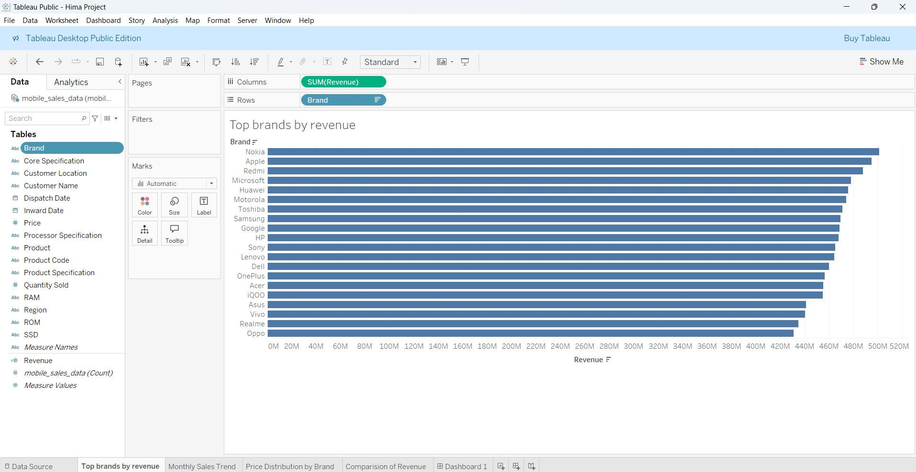

2. How have the monthly sales trends for the mobile brand Acer changed over time?
Step 2: Build the Monthly Sales Trend Chart
- Drag Dispatch Date to the Columns shelf.
  - Right-click on the field → select Month for a continuous timeline.
- Drag Quantity Sold to the Rows shelf.
  - The default aggregation should be SUM(Quantity Sold).
- Apply a Filter for a Specific Brand (e.g., Acer):
  - Drag the Brand field to the Filters shelf.
  - In the dialog, check the box for Acer.
- Drag Brand to Color or Detail (optional):
  - In the Marks card, drag Brand to Color or Label to display the brand name.
- Format the Chart:
  - Add a title: "Monthly Sales Trend"
  - Right-click axis to format date range and spacing.
  - Clean up gridlines and adjust font if needed.
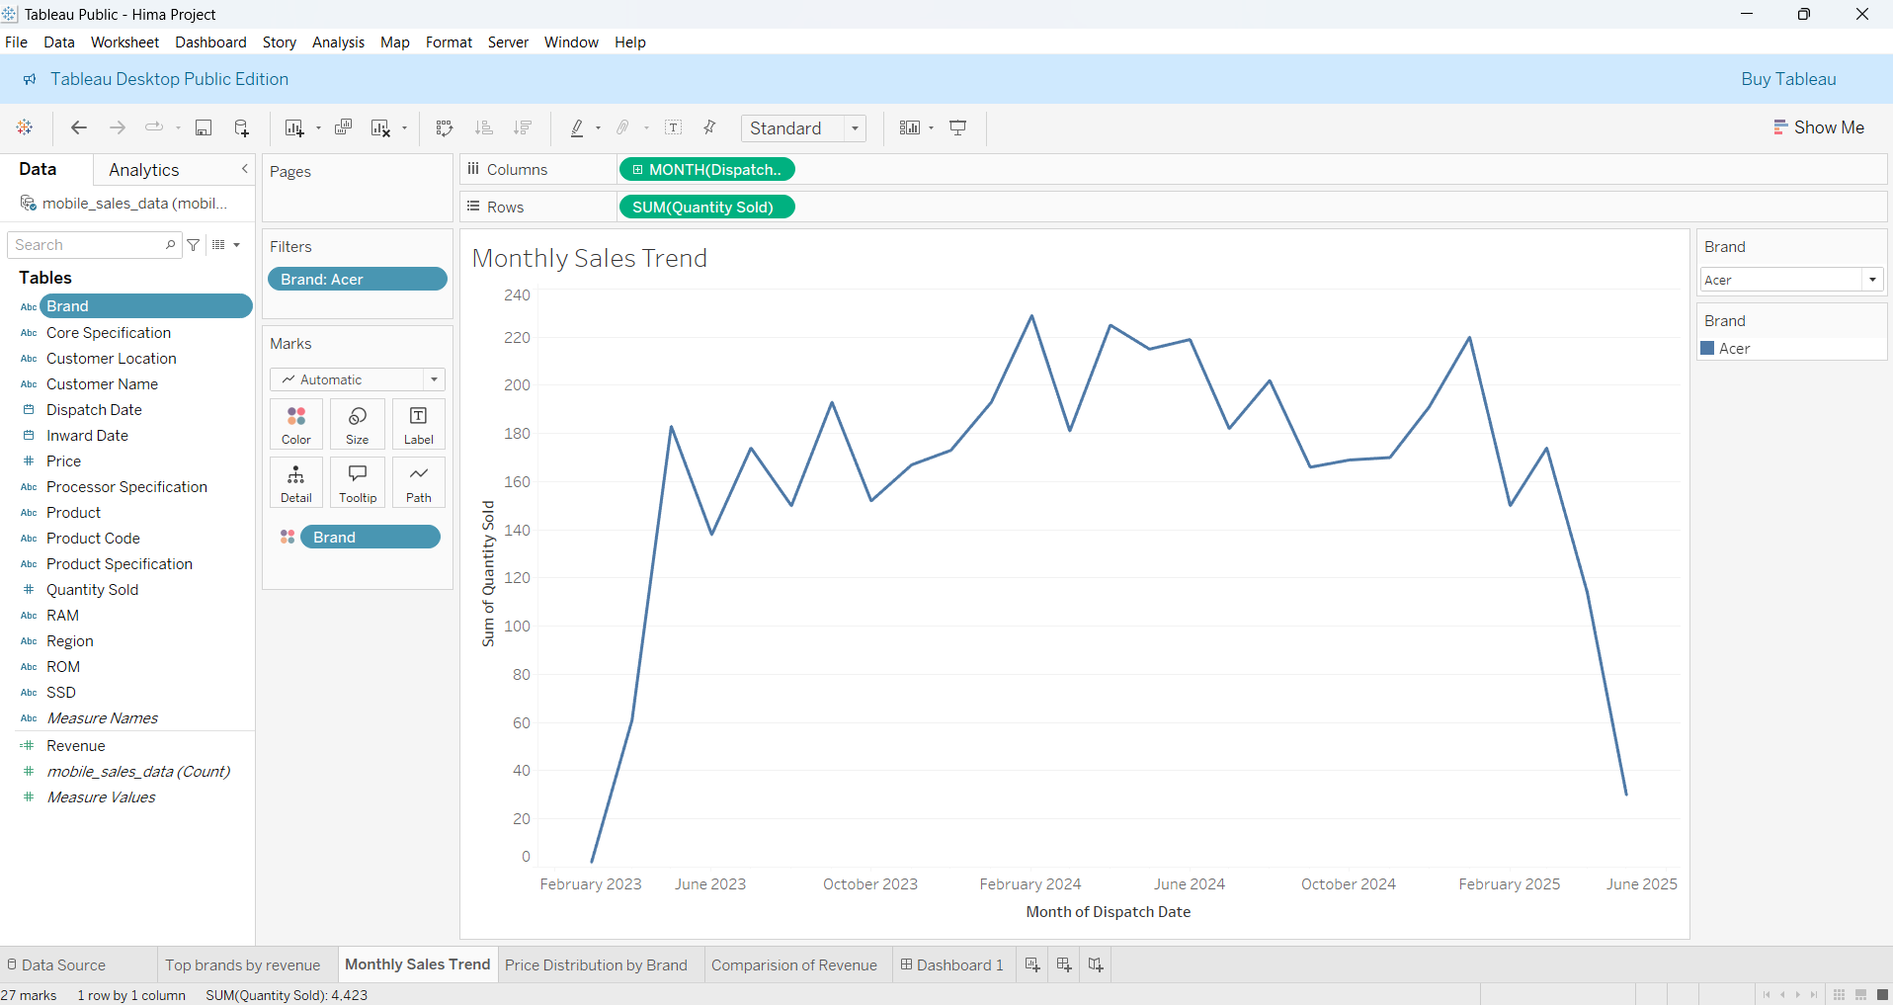

- How is the total price distribution of different mobile brands represented in the market?
Step 1: Set Up the Pie Chart
- Change the Marks type to Pie:
  - Go to the Marks card and select Pie from the dropdown.
- Drag Brand to the Columns Shelf (or directly into the Marks card as Color).
- Drag Price to the Angle shelf on the Marks card:
  - This determines the slice size of each brand based on total price.
- Drag Price again to the Label or Tooltip shelf to show total price values.
- Drag Brand to the Color shelf to differentiate each brand.
Step 2: Adjust Filters and Layout
- (Optional) Drag Brand into the Filters shelf to include only selected brands.
- Resize the pie chart by enlarging the view in the workspace.
- Add a title: "Price Distribution by Brand".
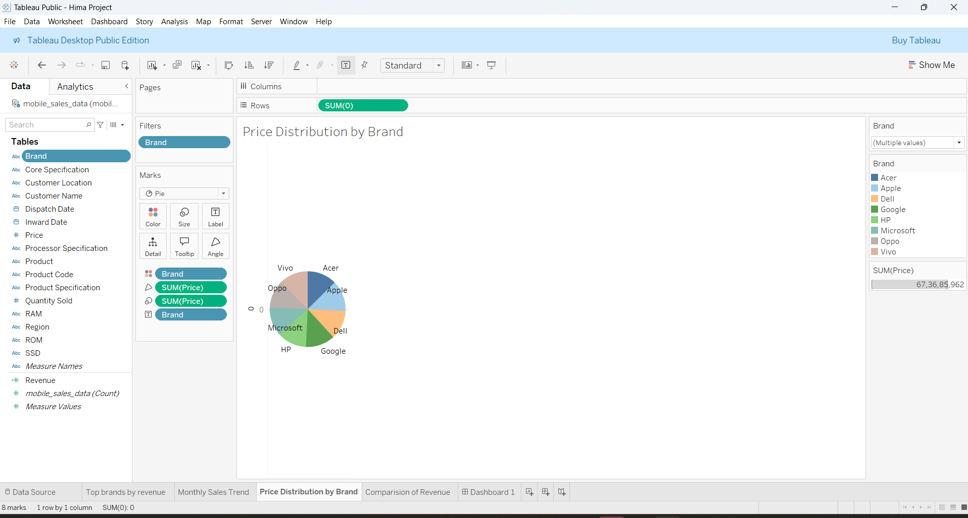

4.what trend can be observed in HP’s revenue from 2023 to 2025?
Explore fields like Brand, Revenue, Dispatch Date, Quantity Sold, etc.
Drag YEAR(Dispatch Date) to Columns.
Drag SUM(Revenue) to Rows.
Drag Brand to Filters and choose HP.
Use the Line chart type from the Marks card.
Rename the sheet to "Comparison of Revenue".
Add title: “Comparison of Revenue”.
Use filters to include the years 2023, 2024, and 2025.
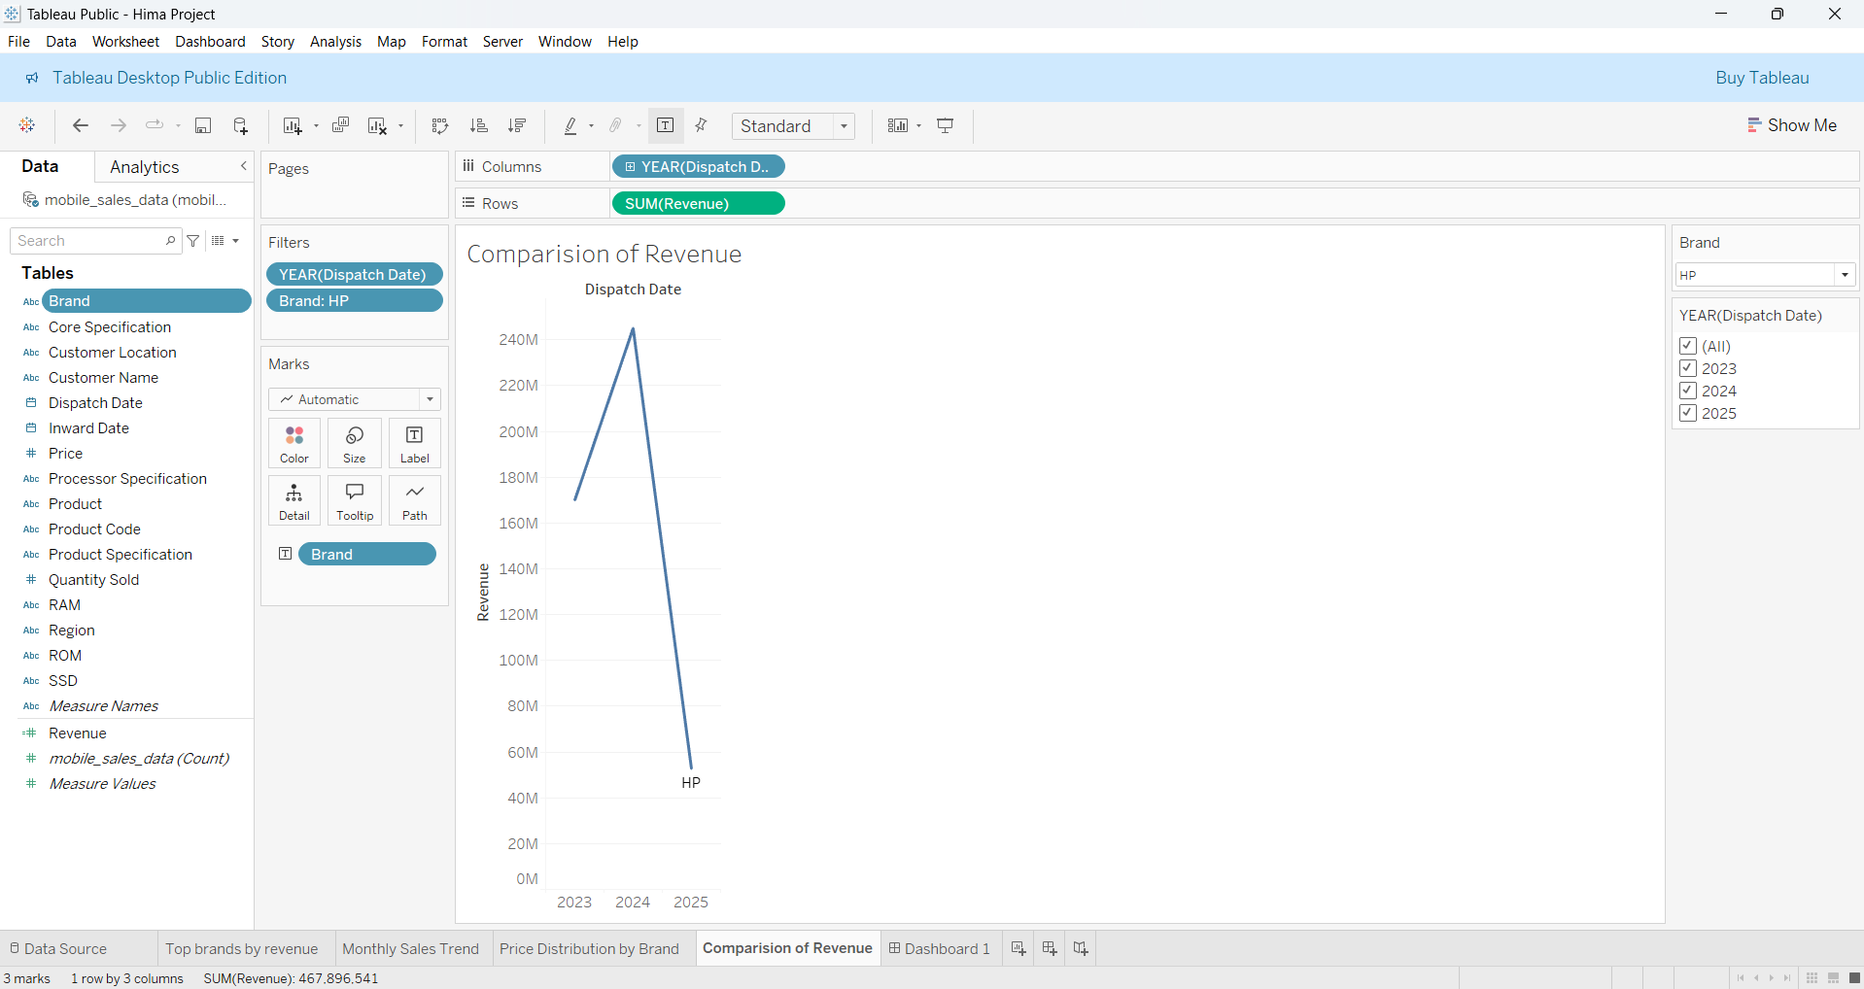

Dashboard:
1. Click the Dashboard tab and create a new dashboard.
2. Set the size (as per your layout, e.g., 1620 pixels width).
3. Drag the following sheets into the dashboard:
Monthly Sales Trend (top left)
Top Brands by Revenue (top right)
Price Distribution by Brand (bottom left)
Comparison of Revenue (bottom right)
